TASK 12 – DAY-4 DESIGN CHALLENGE
Course Code: CSA04
Course Name: Operating Systems
Course Outcome: CO1
Marks: 8
Full Question
The hospital is adding remote patient monitoring at home and a cloud-based records service.
Re-evaluate the original operating-system design and determine whether it should be retained, modified or redesigned.
The answer should include:
- A. Impact Analysis (2 Marks): Analyze the OS types, services and security requirements.
- B. Evaluation of Original Plan (2 Marks): Evaluate the original plan based on latency, reliability and security.
- C. Adaptation and Redesign (2 Marks): Adapt the design for embedded RTOS devices at home and distributed cloud-based patient records.
- D. Defense of Design (2 Marks): Justify the trade-offs using evidence and explain the design decisions.
AIM
To redesign the smart hospital operating-system plan for remote patient monitoring and cloud-based patient records while maintaining reliability, security and timely response.
ANSWER
A. Impact Analysis
1. Introduction
The hospital is expanding its services by introducing remote patient monitoring and cloud-based patient records.
Remote monitoring allows patients to use medical devices at home. These devices collect readings such as heart rate, blood pressure and oxygen saturation and transmit them to healthcare professionals.
Cloud-based records allow doctors from different hospitals to access authorized patient information.
This expansion introduces new requirements related to response time, connectivity, reliability, security and scalability.
2. Impact on Operating-System Requirements
Requirement | Home Monitoring Devices | Cloud-Based Records
Response time | Fast alarm detection | Fast record retrieval
Reliability | Continuous monitoring | High service availability
Memory | Limited memory | Large memory capacity
Security | Device authentication | Strong access control
Communication | Wi-Fi or cellular network | Secure network communication
Scalability | Supports many devices | Supports many hospitals
Power consumption | Low power | Efficient server operation
3. Required OS Services
Home monitoring devices require:
- Real-time scheduling.
- Sensor and device management.
- Interrupt handling.
- Network communication.
- Memory management.
- Security services.
Cloud-based records require:
- Process management.
- Database services.
- File management.
- Network communication.
- Authentication and authorization.
- Backup and recovery.
- Resource allocation.
4. Security Requirements
Remote patient monitoring introduces security risks because data is transmitted through external networks.
Security measures include:
- Device authentication.
- Encryption of patient data.
- Secure communication protocols.
- Role-based access control.
- Audit logs.
- Regular security updates.
- Secure storage of patient records.
These measures prevent unauthorized access and protect patient privacy.
B. Evaluation of the Original Plan
1. Original Operating-System Plan
The original plan uses:
- Real-time OS for bedside monitors.
- Handheld OS for nurses’ tablets.
- Desktop OS for doctors’ workstations.
- Clustered Linux for the database server.
- Multiprocessor Linux for MRI imaging.
- Distributed systems for partner hospital communication.
This plan is suitable for the hospital's internal computing environment.
However, remote patient monitoring and cloud-based services require additional modifications.
2. Evaluation Based on Latency
Remote monitoring devices may communicate through Wi-Fi or cellular networks.
Network delay can vary because of:
- Network congestion.
- Signal strength.
- Internet connection failures.
- Distance from network infrastructure.
Therefore, the device should not depend entirely on the cloud to detect an abnormal reading.
Critical alarms must be detected locally using the embedded real-time operating system.
3. Evaluation Based on Reliability
Cloud services improve scalability and allow multiple hospitals to access records.
However, cloud services may become unavailable because of:
- Internet failures.
- Server failures.
- Network congestion.
- Software errors.
The remote device should continue local monitoring even when the internet connection is unavailable.
The cloud service should use redundant servers, backups and fail-over mechanisms.
4. Evaluation Based on Security
Cloud-based patient records introduce additional security risks.
Patient information may be exposed through:
- Unauthorized device access.
- Weak authentication.
- Insecure network connections.
- Misconfigured cloud storage.
Therefore, strong encryption, access control, authentication and monitoring must be implemented.
Evaluation Table
Factor | Original Plan | Required Modification
Latency | Suitable for hospital devices | Local alarm processing for home devices
Reliability | Clustered database | Cloud redundancy and local device operation
Security | Hospital network protection | End-to-end encryption and device authentication
Scalability | Three hospitals | Support large numbers of remote devices
Connectivity | Internal and partner networks | Internet and cellular connectivity

C. Adaptation and Redesign – 2 Marks
1. Redesigned Architecture
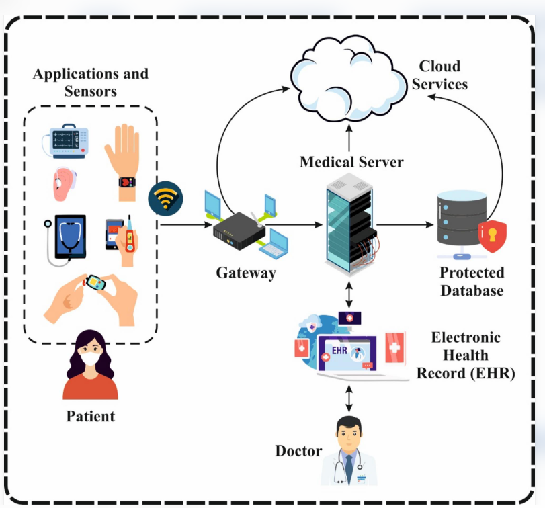
The redesigned system uses a combination of embedded real-time systems, edge processing and cloud-based distributed services.
2. Home Monitoring Devices
An embedded real-time operating system such as FreeRTOS is recommended for home monitoring devices.
The device should:
- Collect sensor readings.
- Detect abnormal readings locally.
- Generate immediate alarms.
- Store readings temporarily.
- Transmit readings securely.
- Continue monitoring during internet failure.
The real-time task should receive the highest priority.
3. Edge Gateway
A home gateway or mobile device can act as an edge system.
Its responsibilities include:
- Collecting data from multiple sensors.
- Performing preliminary processing.
- Encrypting readings.
- Sending data to the cloud.
- Buffering readings during network failure.
Edge processing reduces unnecessary network communication and improves response efficiency.
4. Cloud-Based Patient Records
A distributed cloud system is recommended for storing and sharing patient records.
The cloud service should include:
- Distributed database servers.
- Data replication.
- Secure API communication.
- Authentication and authorization.
- Backup and recovery.
- Monitoring and logging.
The system should allow authorized doctors from partner hospitals to access patient records.
5. Redesigned Operating-System Plan
Component | Recommended OS or System | Main Function
Home medical devices | Embedded RTOS | Local monitoring and alarm response
Home gateway | Embedded Linux | Data collection and communication
Nurses’ tablets | Android | Mobile access
Doctors’ workstations | Windows/Linux | Patient-record access
Cloud database | Clustered Linux | Reliable record storage
Cloud communication | Distributed services | Secure sharing of records
MRI server | Multiprocessor Linux | Medical image processing
6. Data Flow
- Sensors collect patient readings at home.
- The RTOS processes readings locally.
- Abnormal readings trigger local alarms.
- The gateway encrypts and transmits the data.
- Cloud servers receive and store the readings.
- Authorized doctors access patient information.
- The cloud system synchronizes records between hospitals.
If the internet connection fails, the home device continues local monitoring and temporarily stores readings.
D. Defense of the Design – 2 Marks
1. Justification
The redesigned system is suitable because it separates time-critical processing from cloud-based record management.
The embedded RTOS handles local alarms. Cloud servers handle large-scale storage and communication.
This separation improves reliability and reduces dependence on network connectivity.
2. Trade-Off Analysis
Design Decision | Advantage | Trade-Off
Embedded RTOS | Predictable response | Limited memory and services
Edge processing | Faster local decisions | Additional hardware cost
Cloud storage | Scalable data access | Requires network connectivity
Data replication | Improved availability | Additional storage requirements
Encryption | Strong security | Processing overhead
Local buffering | Handles network failures | Requires local storage
3. Latency
Local alarm processing avoids the delay caused by transmitting data to a cloud server and waiting for a response.
Therefore, the system can respond to abnormal readings more quickly.
The actual response time must be verified through testing to ensure the required 10-millisecond deadline is met.
4. Reliability
The device continues to monitor patients during network failures.
Cloud redundancy and database replication improve availability.
Local buffering prevents readings from being lost during temporary communication failures.
5. Security
Encryption protects data during transmission and storage.
Authentication verifies the identity of devices and users.
Role-based access control restricts patient information to authorized healthcare professionals.
Audit logs help detect unauthorized access.
CONCLUSION
The original smart hospital operating-system plan should be modified rather than completely replaced. Embedded real-time operating systems are recommended for home monitoring devices, while edge gateways provide local processing and communication. Cloud-based distributed systems are recommended for patient-record storage and sharing. The redesigned architecture improves latency, reliability, scalability and security while supporting remote patient monitoring and healthcare services across multiple hospitals.

